pmc_select_pmc_unit

声明
/* select PMC unit */
[DllImport("FWLIB32.dll", EntryPoint = "pmc_select_pmc_unit")]
public static extern short pmc_select_pmc_unit(ushort FlibHndl, int a);

描述
Selects PMC that will be the target of other PMC FOCAS2 function by the unit type.

参数
(1)库句柄；[in]
(2) int a PMC单位；[out]
Value | Unit type
PMCUNIT_PMC1 (1) | 1st PMC
PMCUNIT_PMC2 (2) | 2nd PMC
PMCUNIT_PMC3 (3) | 3rd PMC
PMCUNIT_DCS (9) | Dual-check safety PMC

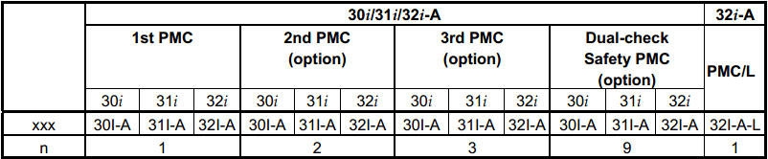

函数返回值

代码
class Program
{
static void Main(string[] args)
{
ushort Flibhndl = 0;

short ret; // 返回值

// 获取库句柄 ( Ethernet )
ret = Focas1.cnc_allclibhndl3("192.168.0.224", 8193, 10, out Flibhndl);
if (ret != Focas1.EW_OK)
{
Console.WriteLine("发生异常，请检查！");
return;
}

#region pmc_select_pmc_unit

short unit = 1;
ret = Focas1.pmc_select_pmc_unit(Flibhndl, unit);

#endregion
}
}

